Pelican Park Recreational Ground  Lambwath Road  HULL. HU8 0EE  Tel: 01482-703114  Email: info@pelicanparkhull.org  Website: www.pelicanparkhull.org | 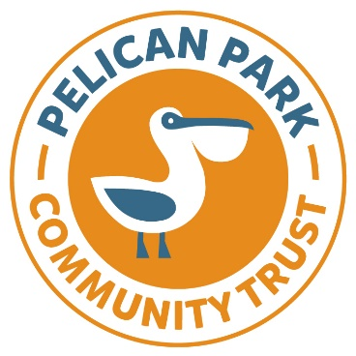
PELICAN PARK COMMUNITY TRUST
SCHOOL HOLIDAY BOOKING FORM SUMMER 2024

Name:
Address:

Post Code:
Telephone Number:
Email:
Date of enquiry:
- Full name of child: Date of Birth:
- Full name of child: Date of Birth:
Please specify what date you would like to book onto the Sport Camps using a tick to indicate each booking.
Weekdays | Week 1  22 July  To  26/7 | Week 2  29 July  To  2nd Aug | Week 3  5 Aug  To  9 Aug | Week 4  12 Aug  To  16 Aug | Week 5  19 Aug  To  23 Aug | Week 6  27 Aug  To  30 Aug
Monday
Tuesday
Wednesday
Thursday
Friday

Payment Information:
The cost of each booking per child is £15, which needs to be paid in advance. You can call the team and pay by card or by visiting the website at www.pelicanparkhull.org.uk.
Further information:
Your child will need to bring a packed-lunch and a drink on the day. Please also make sure they are wearing appropriate clothing for the time of year. Trainers must also be worn.

The gates will open at 9.30am for registration, with sessions starting at 10am until 3pm. Your child must be collected by an authorised adult and the end of each session. There is a 24-hour cancellation of all bookings and must be done by calling the team on telephone: 01482-703114. Please email this booking form to: bookings@pelicanparkhull.org.uk

Thank you

