Pelican Park Recreational Ground  Lambwath Road  HULL. HU8 0EE  Tel: 01482-703114  Email: info@pelicanparkhull.org  Website: www.pelicanparkhull.org | 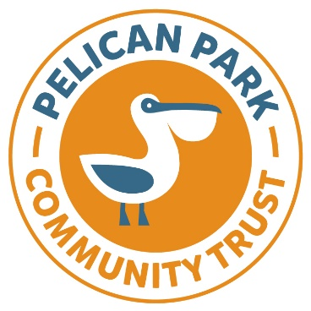
PELICAN PARK COMMUNITY TRUST
LITTLE KICKERS FOOTBALL SESSIONS 2024

Name:
Address:

Post Code:
Telephone Number:
Email:
Date of enquiry:
- Full name of child: Date of Birth:
- Full name of child: Date of Birth:
School/nursery attending:

Medical Information:

Further Information:

Sessions will take place outside on the football pitches. We pride ourselves in offering a safe playing environment for children and young people of all ages.

If you require any further information, please call the team on 01482-703114.

Once completed, please return the form to bookings@pelicanparkhull.org.uk

Thank you.

